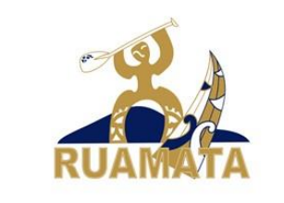
Rotohoe Biosecurity Plan
This to prevent the spread of any invasive species, but in particular, the Freshwater Gold Clam (Corbicula fluminea) by our event – both by our event equipment and by participants’ equipment.
All kaihoe are expected to follow best practice Check Clean Dry (CCD) procedures as set out in the Waka Ama NZ Freshwater Gold Clam Info Sheet (see next page).
This includes removing bungs from all waka and draining bulkheads/hulls of W1 and W6. If it is not possible to completely drain bulkheads/hulls, bleach must be added. Kaihoe will be required to sign a waiver indicating that they have followed the carried out appropriate treatment of waka, PFDs and hoe.
Furthermore, kaihoe participating in the Rotohoe Series will also be assessed as being at one of three levels of risk, depending on the waterway they and their waka & equipment have been used on.
High risk
- Kaihoe coming from ‘high risk’ areas i.e. anywhere along the Waikato River and Lake Taupō will be identified through the registration process and biosecurity procedures will be communicated via email in the weeks leading up to the race. All kaihoe must self-identify if their waka has been on the Waikato River in the 30 days prior to the Rotohoe race and follow the following procedures:
Any waka from “the clam zone” (i.e. anywhere along the Waikato River) will be required to be washed at The Wash Place located at 338 Te Ngae Road and after being washed at The Wash Place:
i. Scanned the QR Code displayed within each wash bay at The Wash Place using a mobile device and filled out the online form that opens on their mobile device; or
ii. Taken a video on a mobile device showing that they washed their craft at The Wash Place
- Where possible hire equipment from Rotorua clubs.
- Follow good practice (CCD) on return home.
Medium Risk
Any waka from other North Island lakes, rivers, and estuaries that contain a large amount of freshwater – i.e. Whanganui, Whakatane are to follow ‘Clam specific CCD’ instructions for entry to Te Arawa Lakes (including Lake Rotorua). For return home ‘Clam specific CCD’ is also required.
Low Risk
Any waka and equipment used on Te Arawa Lakes & from saltwater locations with minimal freshwater input. CCD procedure is recommended as following best practice.
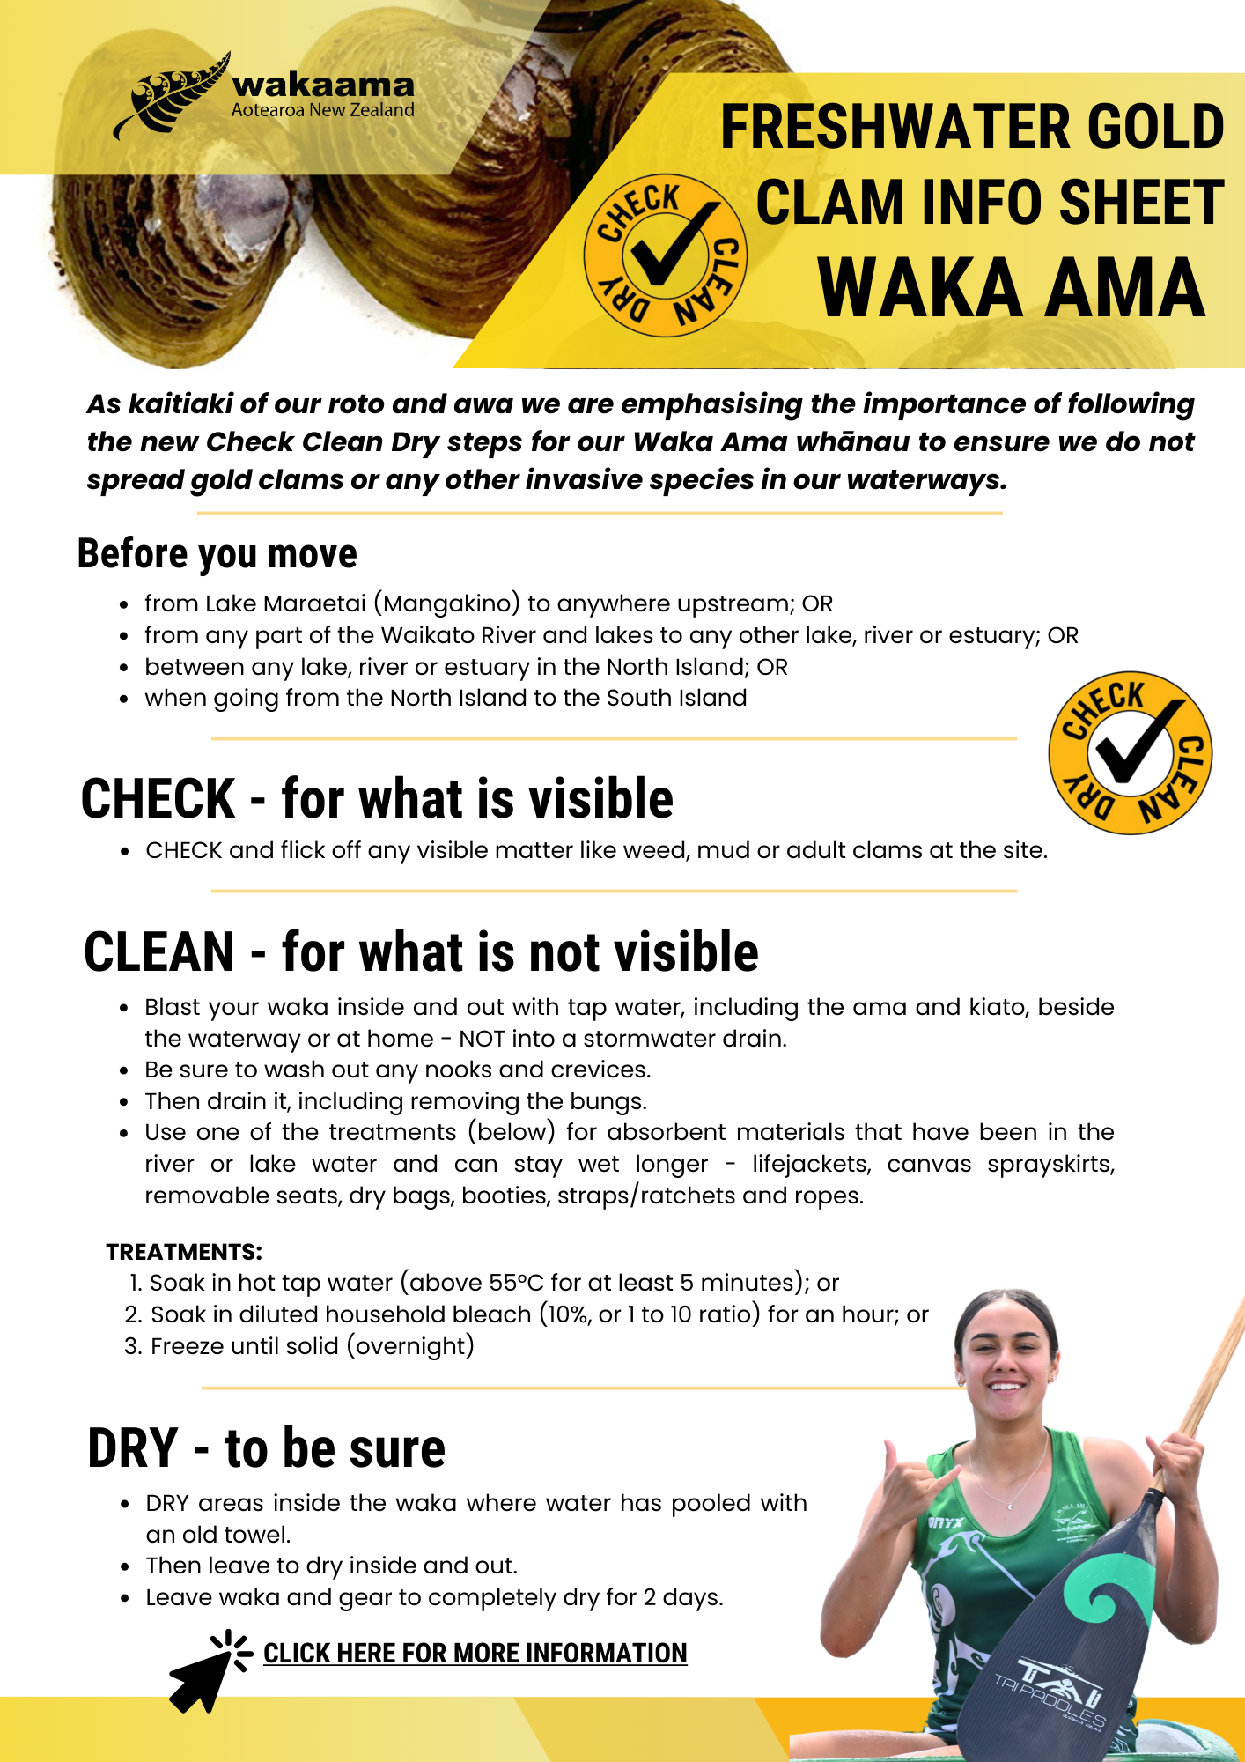
https://www.mpi.govt.nz/biosecurity/exotic-pests-and-diseases-in-new-zealand/pests-and-diseases-under-response/freshwater-gold-clam/

